Jordan Group 1 Data Analysis for Read Me

# “Has the number of house sales in Norwood and Burnside changed from 2018-2022?”

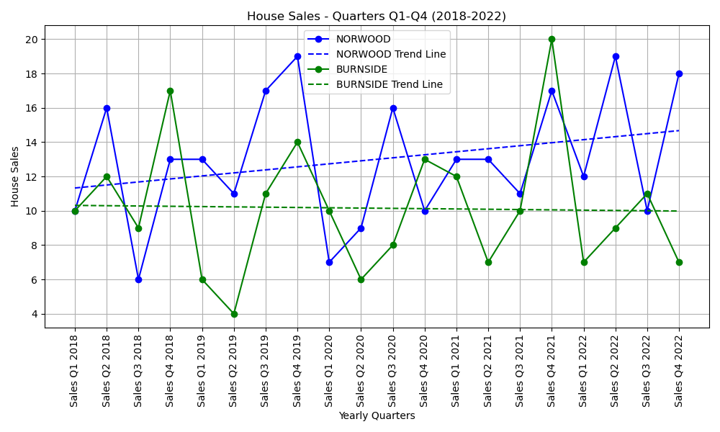

In looking at the line plot comparing House Sales with Yearly Quarters, we can see two separate trendlines for the two selected suburbs. Norwood’s house sales are on a steady increase from 2018-2022 whereas Burnside’s are on a slight decrease. In seeing these trendlines, we might expect to see similar trends for the two suburb’s median house prices as perhaps if a suburb is selling more houses, house prices may begin increasing due to the suburb’s popularity?

# “Has the median house price in Norwood and Burnside changed from 2018-2022?”

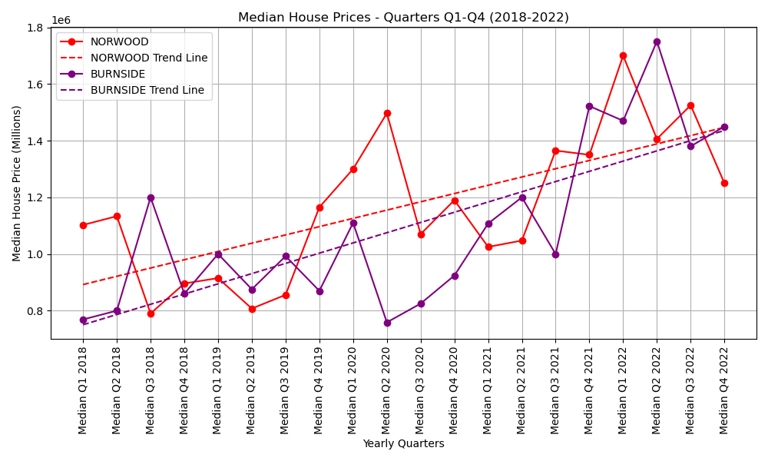

Both suburbs have sharp increases in median house price from 2018-2022, and even though Burnside’s house sales are on a slow decline, their median house price is increasing at a faster rate than Norwood, to a point where Burnside’s median house price was around $100,000 cheaper than Norwood’s at the start of 2018, and by the end of 2022 they were the same, at between 1.4 and 1.5 million dollars.

# “Has the number of house sales impacted the median house price in Norwood and Burnside from 2018-2022?”

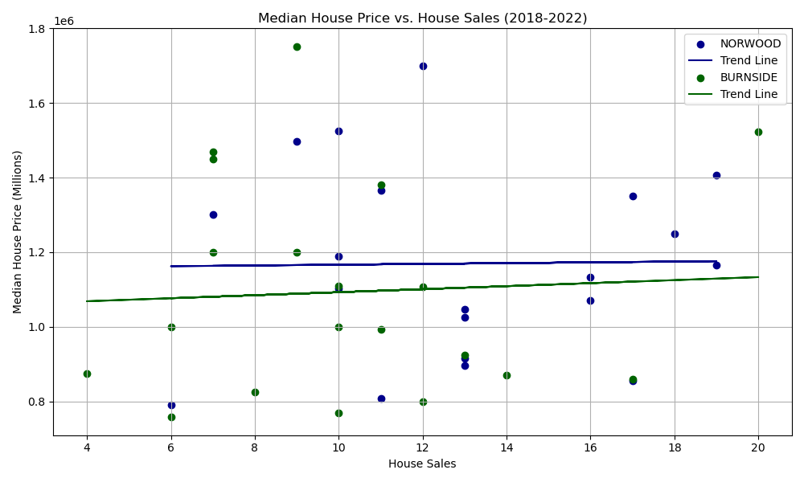

Looking at the scatter plot, we can see that the trendlines are quite flat. Norwood’s trendline is completely flat, meaning that the number of house sales in Norwood does not affect the median house price. In Burnside, the trendline has a very slight increase, but the increase is too small to say that the number of house sales affects the median house price in Burnside.

What this means is that the number of house sales does not play a crucial role in the median house price of Norwood and Burnside and that the increase in median house price in both suburbs post-COVID is likely due to other outside factors.